The People’s Assembly, convening on the 27th of January 2026 under the 58th PA Meeting.

The Assembly, recognising the current situation,

Constitutes the need to recognise Liberdade with RedPanda_4 as head representative and the color being light blue. This to have one more nation. Its borders are found outlined in red in appendix A.

And proceeds.

Signed by,
RedPanda_4

[Motion 58-2: To recognise Liberdade]

APPENDIX A: Borders (red outline)
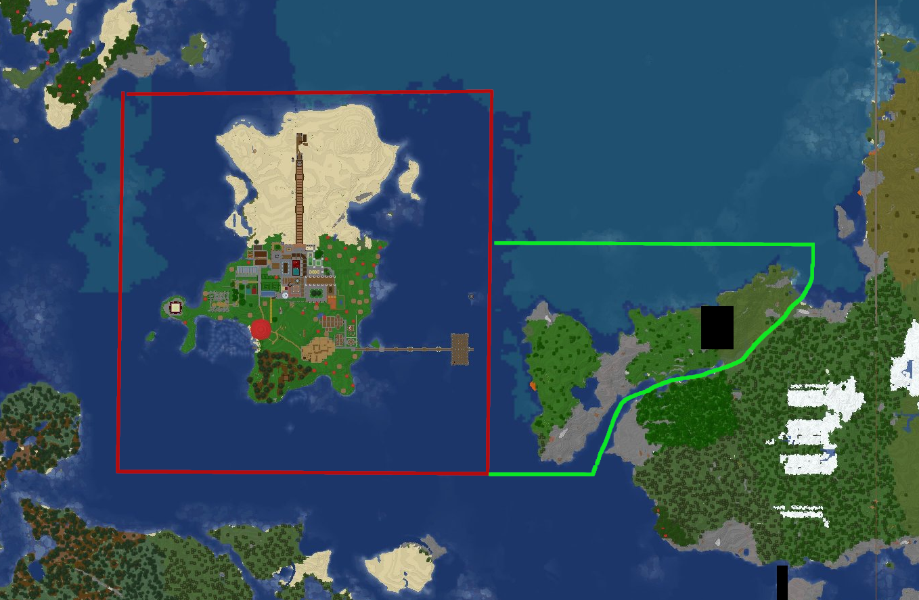
Continues on next page
